07^{h} November 2016

Niels Langeveld Crowned SEAT Leon Eurocup Champion 2016

The Dutchman Niels Langeveld (Baporo Motorsport) concluded a triumphant season winning the title with five wins, three Pole Positions and a third place while Mikel Azcona (PCR Sport) managed two good final races in Barcelona to reach the second place in the international series which is sanctioned by the FIA and has YOKOHAMA as exclusive tyre supplier. The high hopes of the Norwegian Stian Paulsen (Stian Paulsen Racing), who had fought well and hard throughout the competition were dampened when he had to finally settle for third place overall after suffering some bumper action which forced him to abandon in lap 1 of the second race in Catalunya and dash all hopes of the title.

Niels Langeveld (Baporo Motorsport) had shown consistency throughout all race weekends and the Barcelona-Catalunya circuit was no different. In front of over 12.000 fans he produced a meritorious first race with the top spot, but closely followed by the talented Stian Paulsen, refusing to offer his biggest rival an easy victory. Paulsen had been shadowing Langeveld and Briche who had dominated most of the first race.

After obtaining his fifth victory in Saturday’s race 1, the Baporo Motorsport driver crossed the finish line in fifth position on Sunday’s race, which earned him a comfortable overall advantage of 14 points over the runner-up in the final standings.

“I still cannot believe it! This was our objective and what we were fighting for the whole season and to win the SEAT Leon Eurocup, with the high level of the series, is a dream for me.” Exclaimed a delighted Langeveld after the presentation ceremony.

From our side, as tyre suppliers, we are also very pleased with the performance of our tyres and the compliments received from the drivers. We would like to thank all of them and their teams and SEAT for a very exciting series, added David Oliva, Communications Manager for YOKOHAMA Europe.

Final Standings SEAT LEON Eurocup 2016

1. Niels Langeveld 240 points

2. Mikel Azcona 226 points

3. Stian Paulsen 210 points

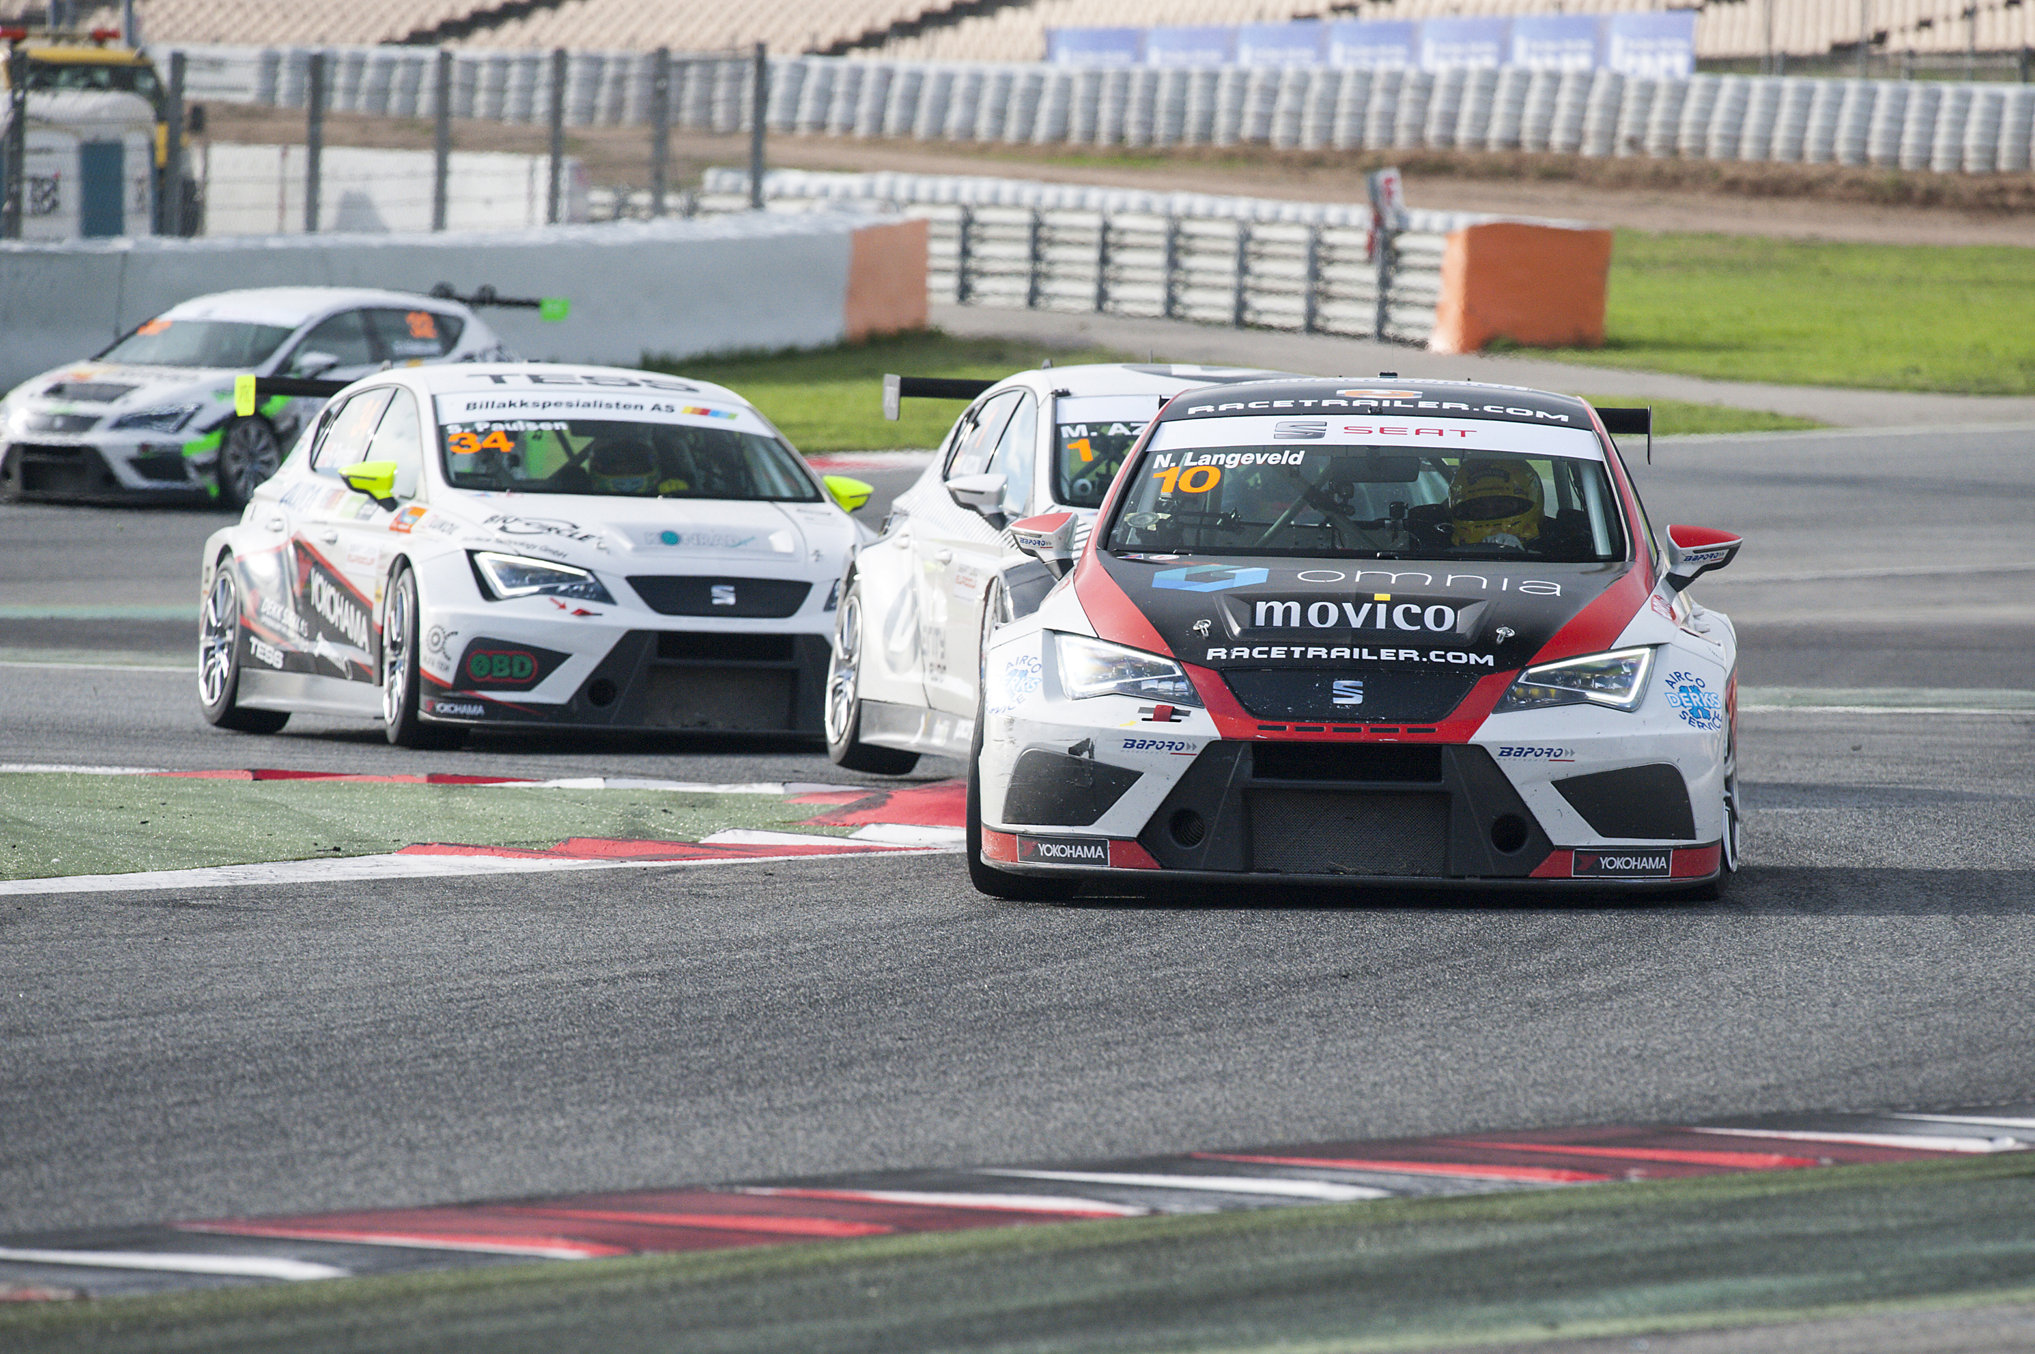
SEAT Leon Eurocup - Barcelona- langeveld-azcona-paulsen

